Jordon Ballou

Lab 5 in lab assignment

Thurs Lab 6pm

1. -bash: simple.sh: command not found

2. -bash: ./simple.sh: Permission denied

3.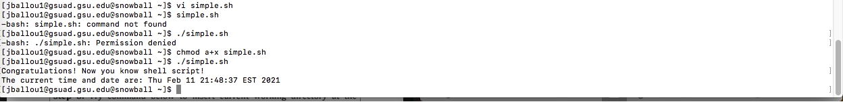

4. -n option in echo command does not append a new line at the end. i.e. it suppresses the default new line character at the end.

5. yes it is

6. no. it means the script should always be run with bash shell than another shell.

Part 2:

7. 5

8. no, The dot (.) refers to the current working directory. The simple.sh is in the current directory so you run it.

9. no I didn’t find current working directory in PATH variable

10. no